



**INDEX**

| **S. No.** | **Contents** | | **Page No.** |
| --- | --- | --- | --- |
| O1. | Project Description | | 02 |
| 02. | Transformation Used | | 03 - 12 |
|  |  | Filter | 03-04 |
|  |  | Router | 04-05 |
|  |  | Aggregation | 05-06 |
|  |  | Expression | 06-07 |
|  |  | Join | 08-09 |
|  |  | Union | 09-10 |
|  |  | Sequence | 10-11 |
|  |  | Sort | 11-12 |

**Supervised By**

***Mr. Pranay***

**Group Members :**

* Mr. Rudra Pratap Singh
* Mr. Utkarsh Rathor
* Mr. Varan Kumar Gupta
* Mr. Vishal Gaur
* Mr. Vishal Singh

***PROJECT DESCRIPTION***

The project involves data transformation using Informatica Power-Center.

**Steps involved in performing the Mapping :**

* Mapping of source table and target table.
* Implementation of filters and router function.
* Implementation of aggregation and expression.
* Implementation of joiner and union.
* Implementation of sequence and sort.

***TRANSFORMATION***

1. **FILTER Transformation :**

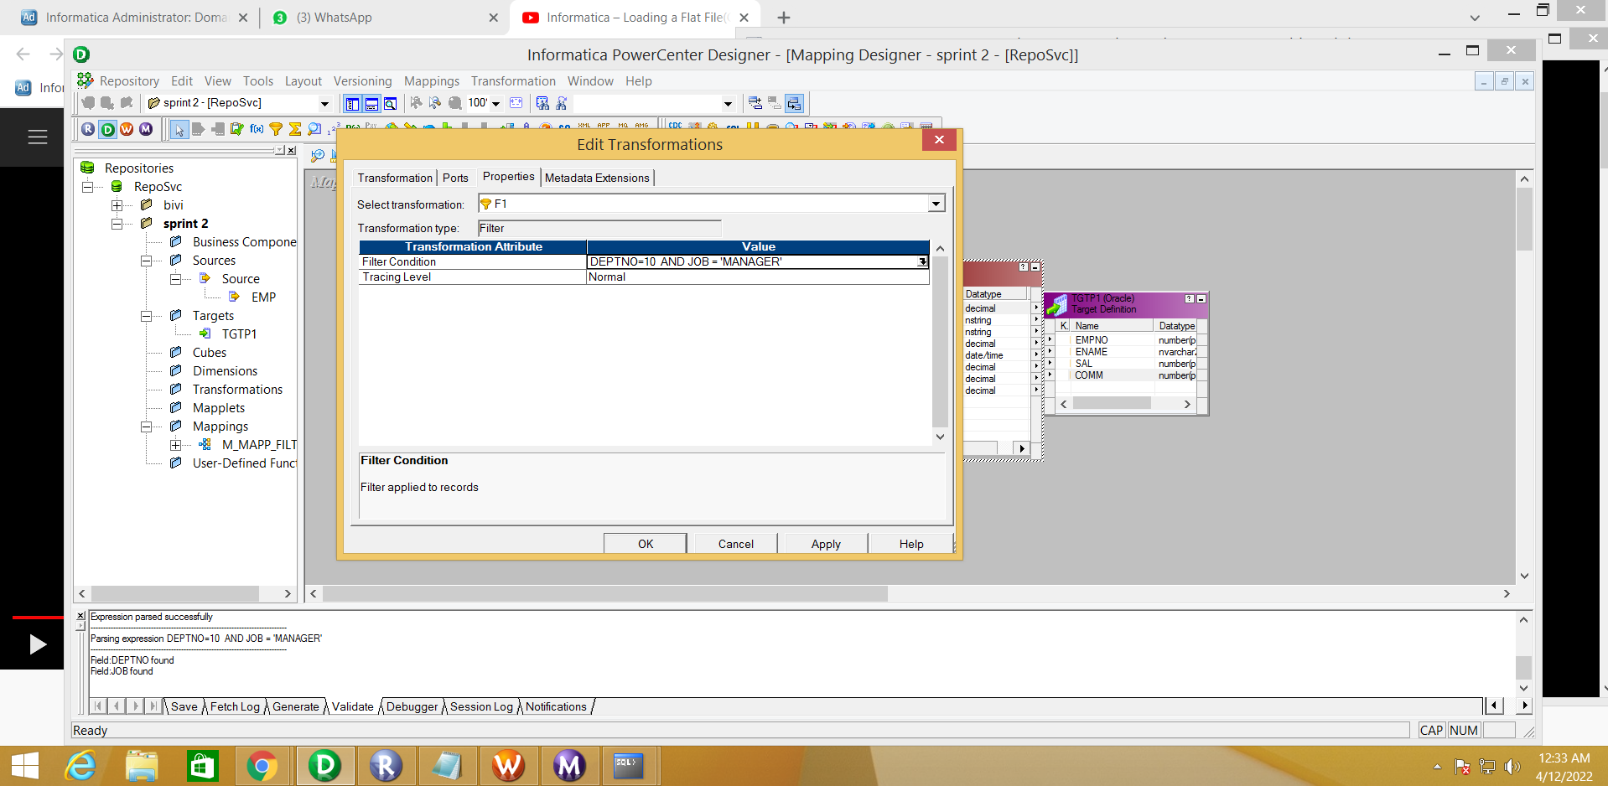

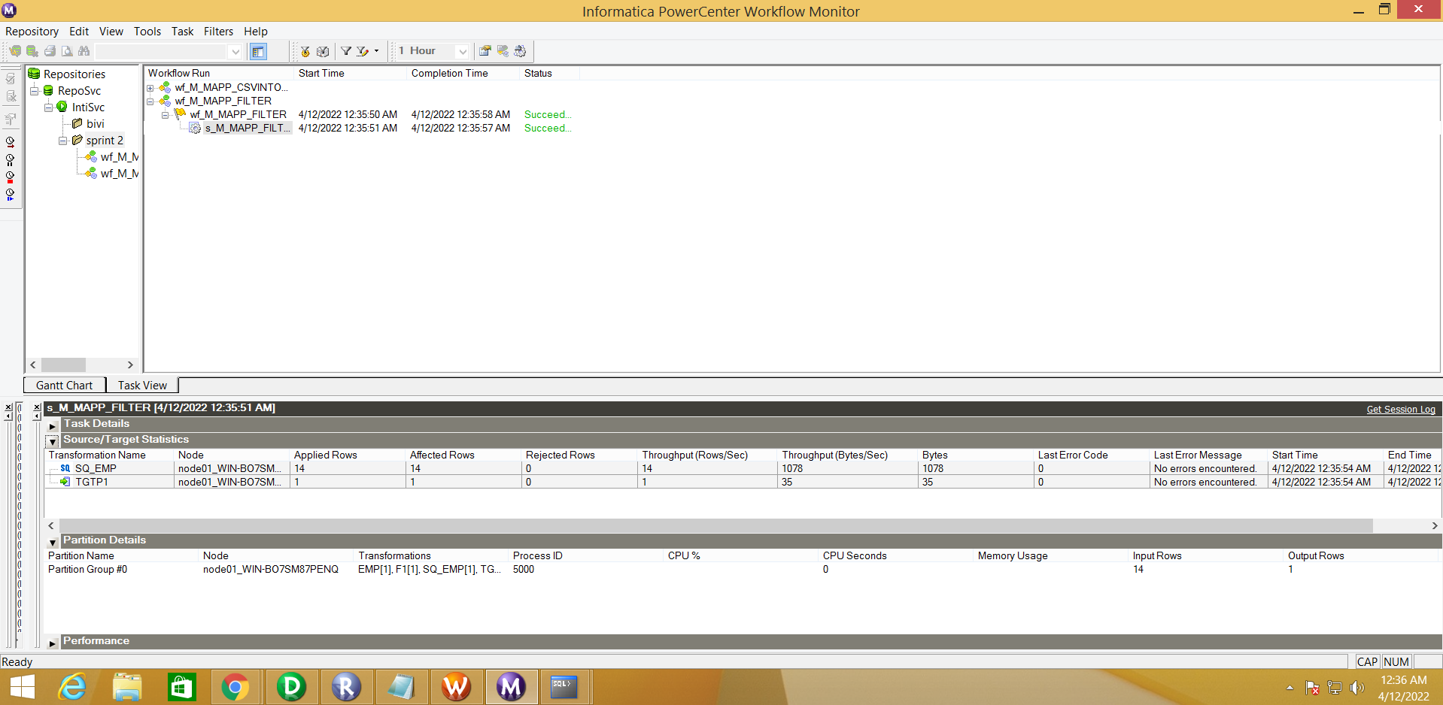

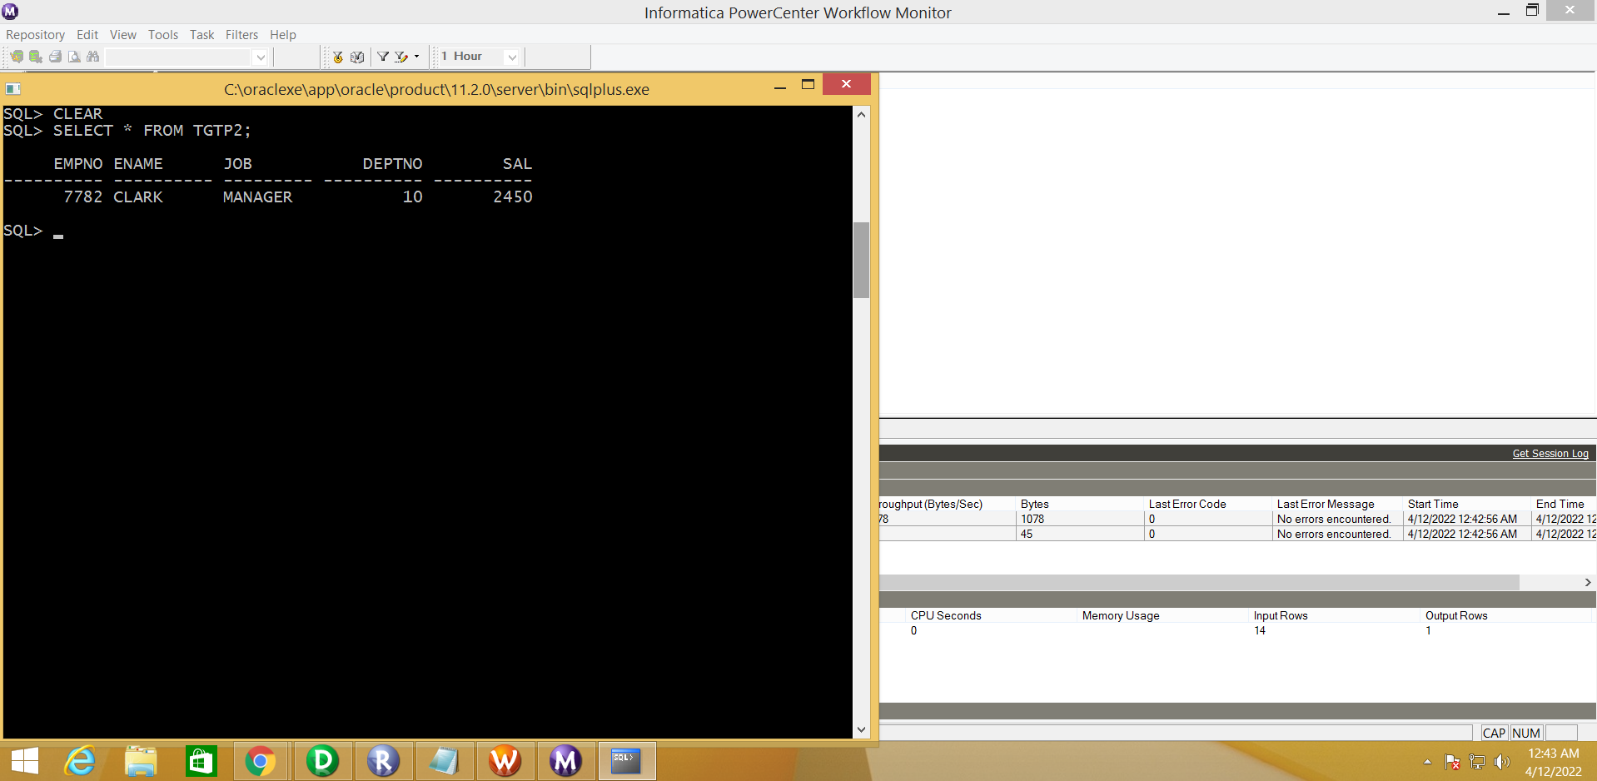

1. **ROUTER Transformation :**

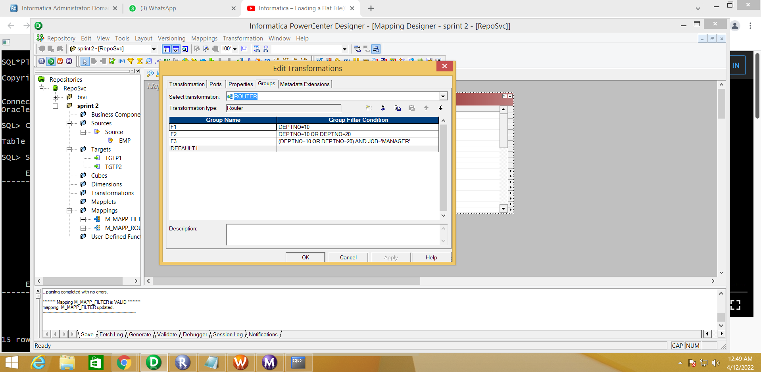

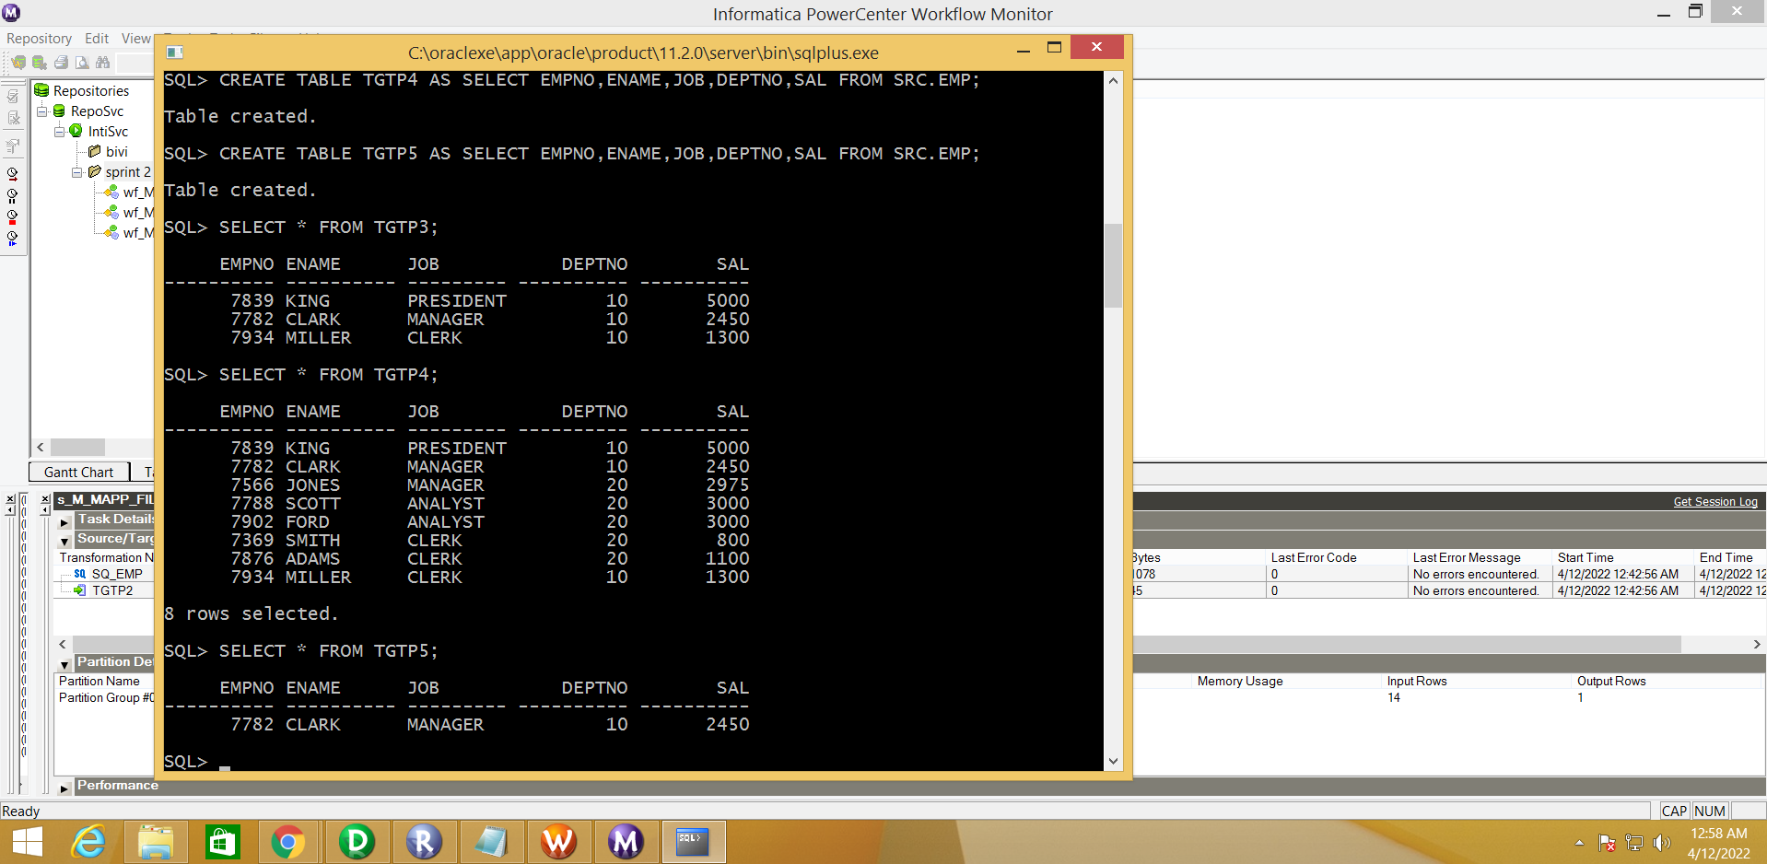

1. **AGGREGATION Transformation :**

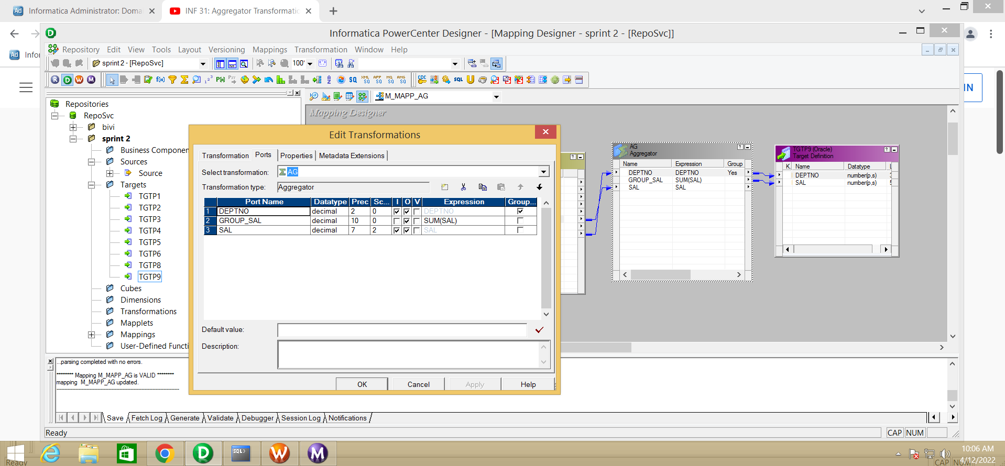

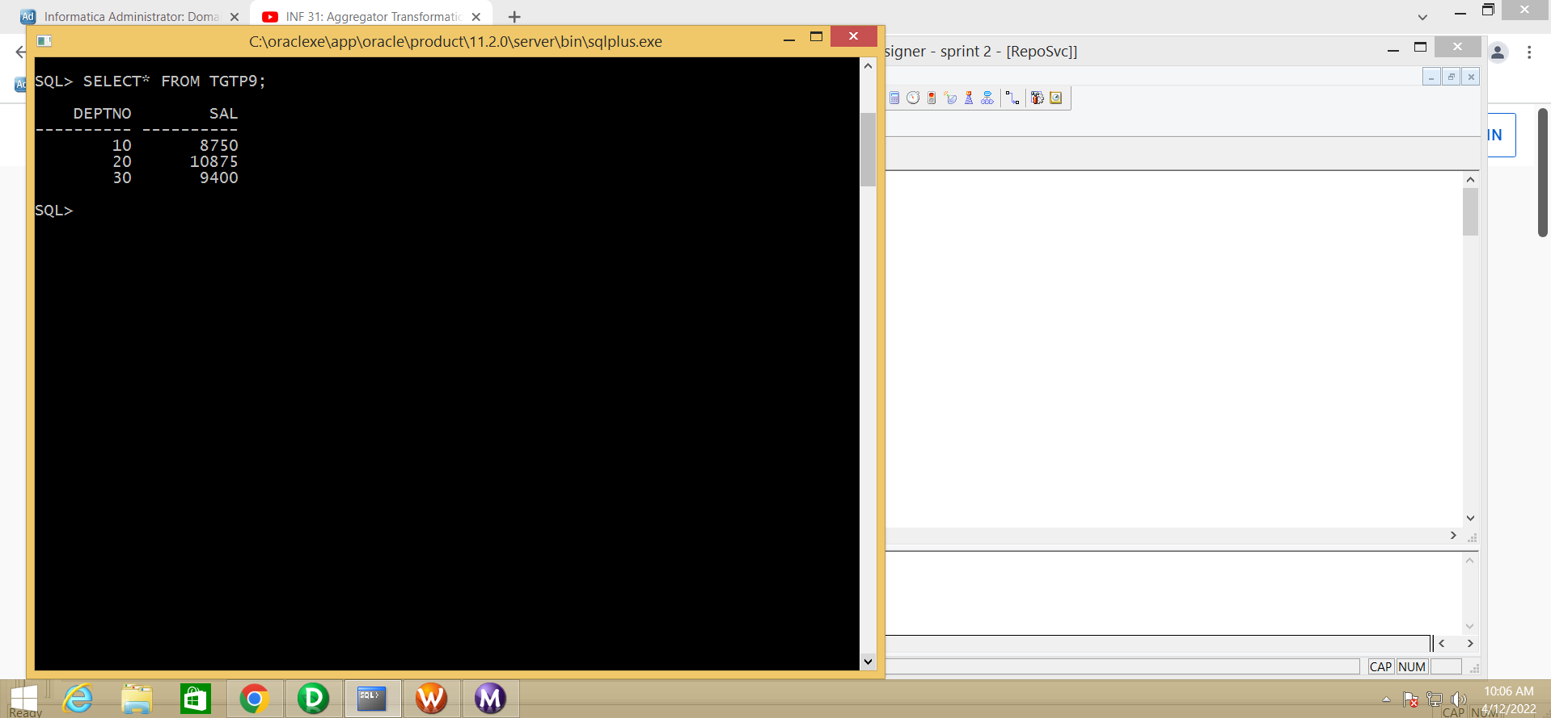

**4. EXPRESSION Transformation :**

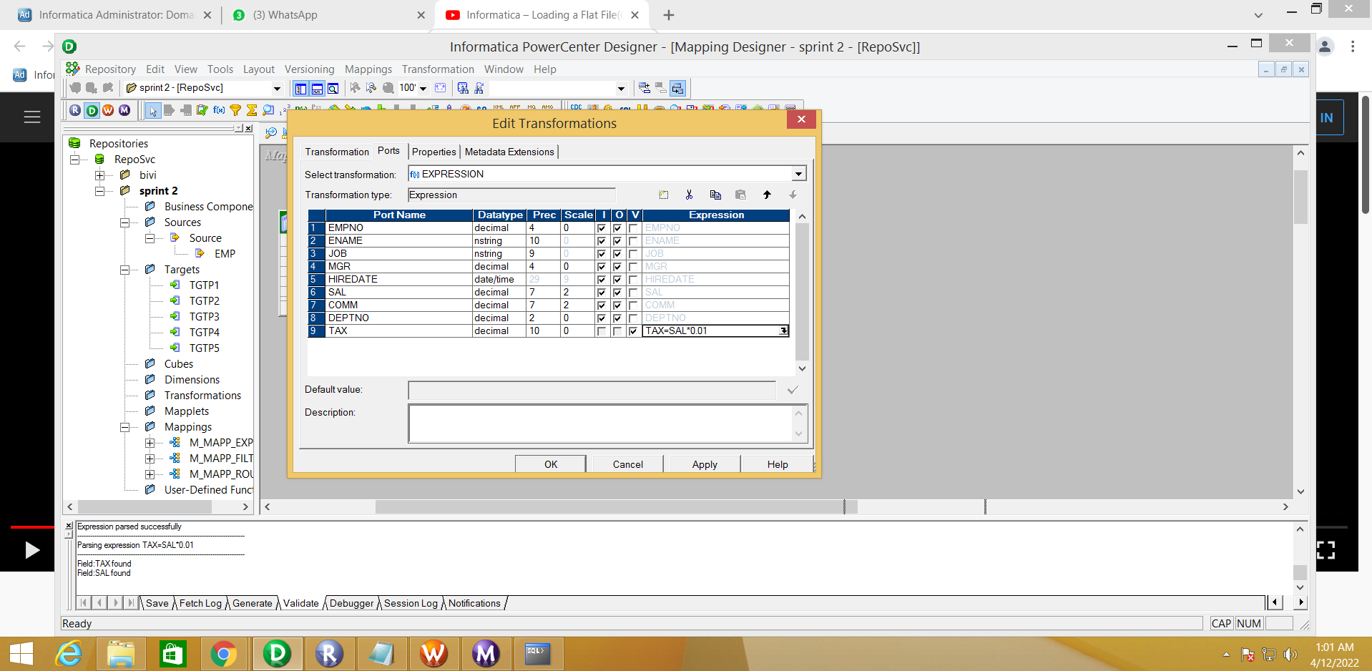

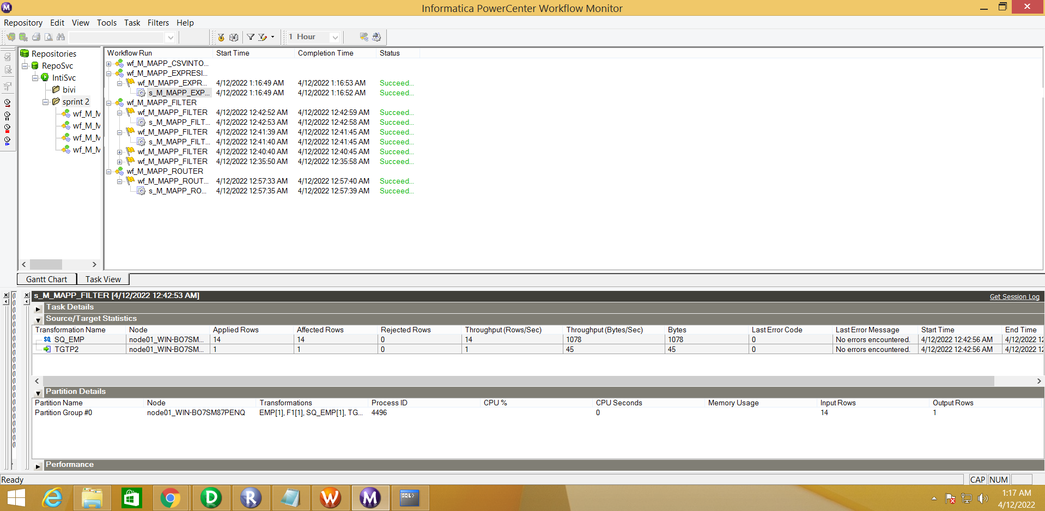  
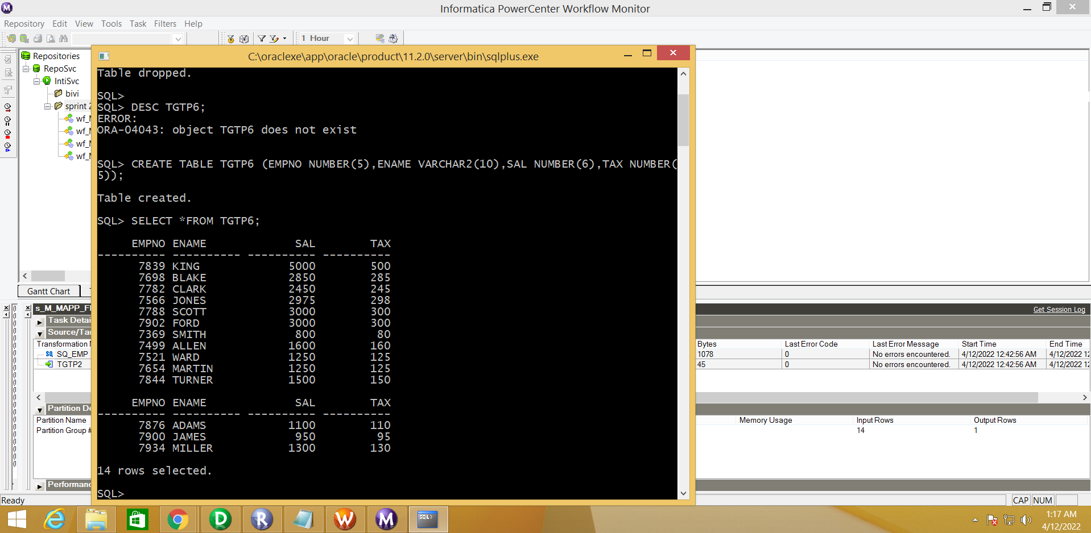

**5. JOINER Transformation :**

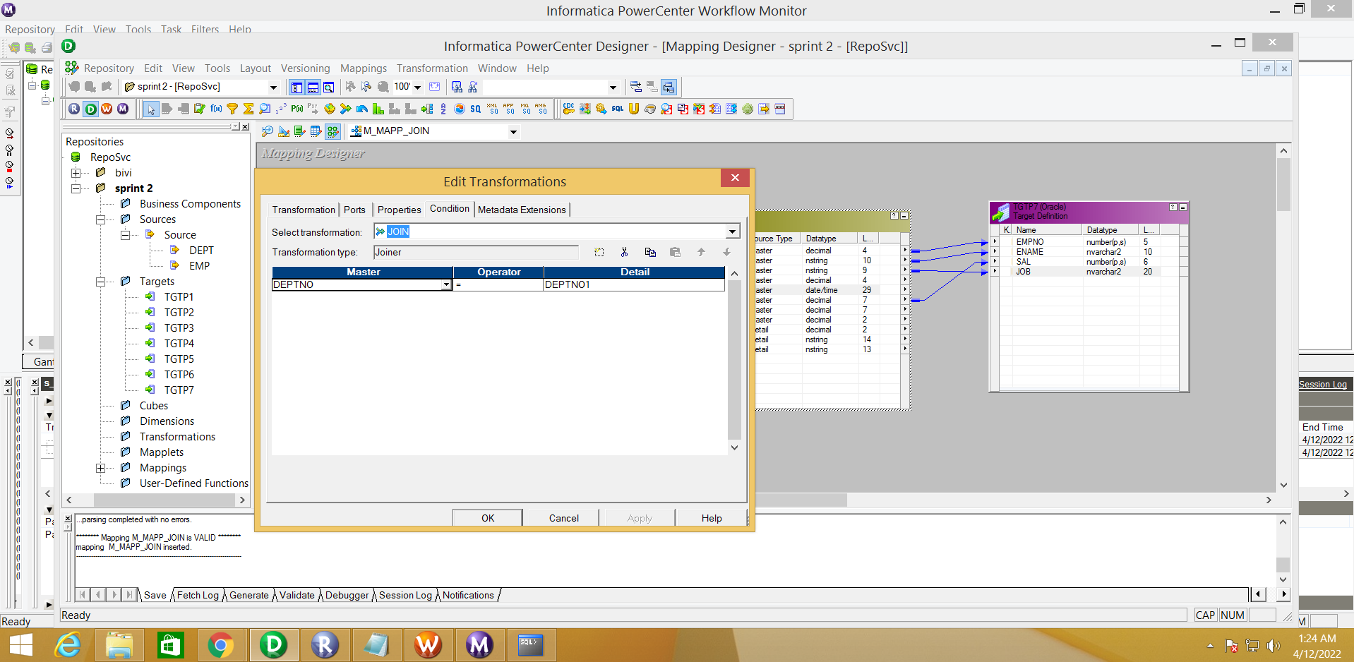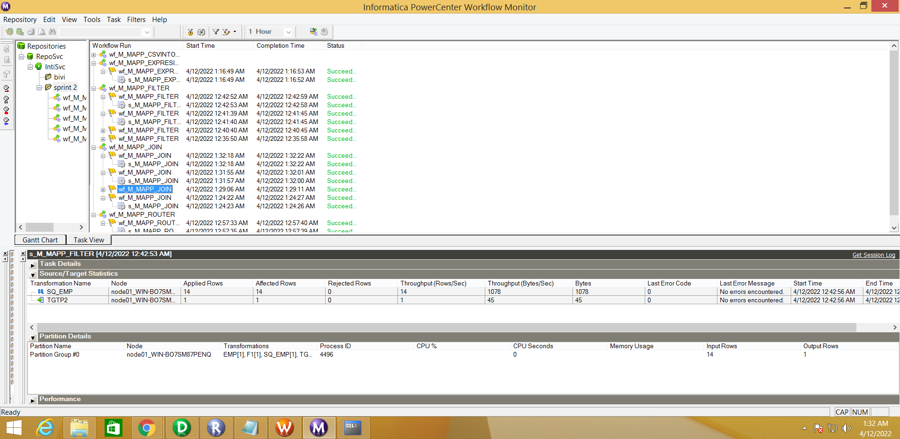

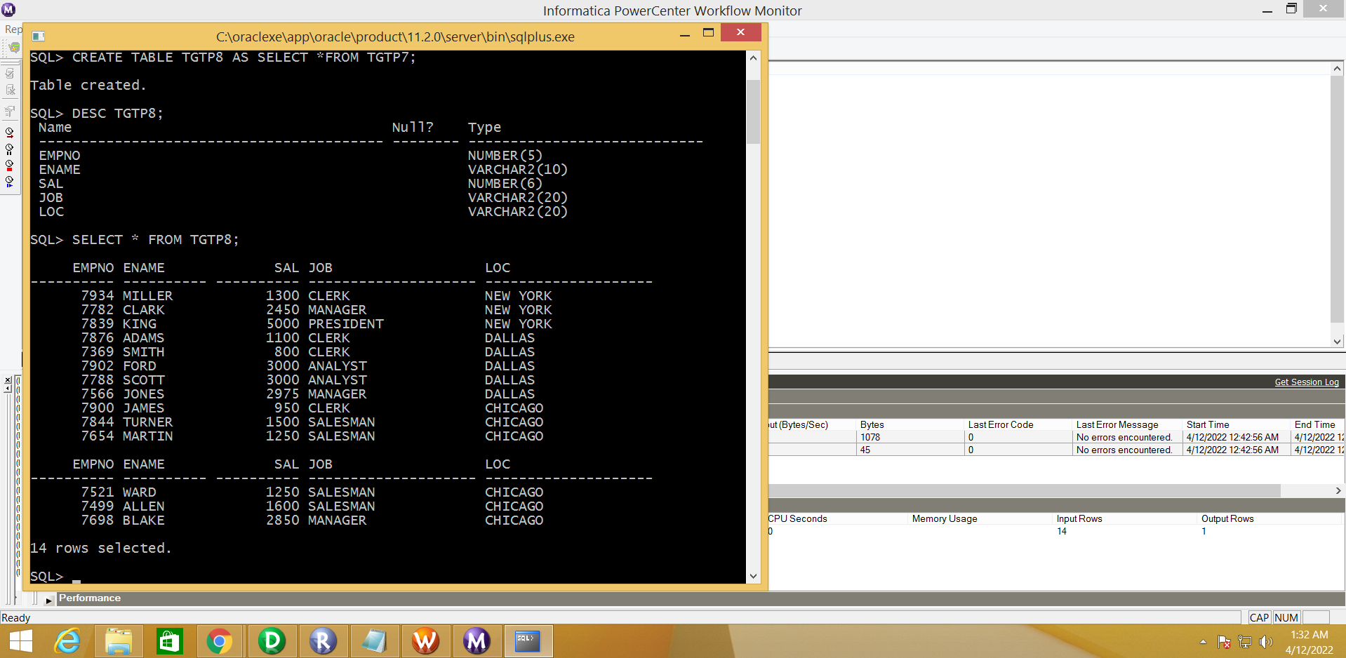

**6. UNION Transformation :**

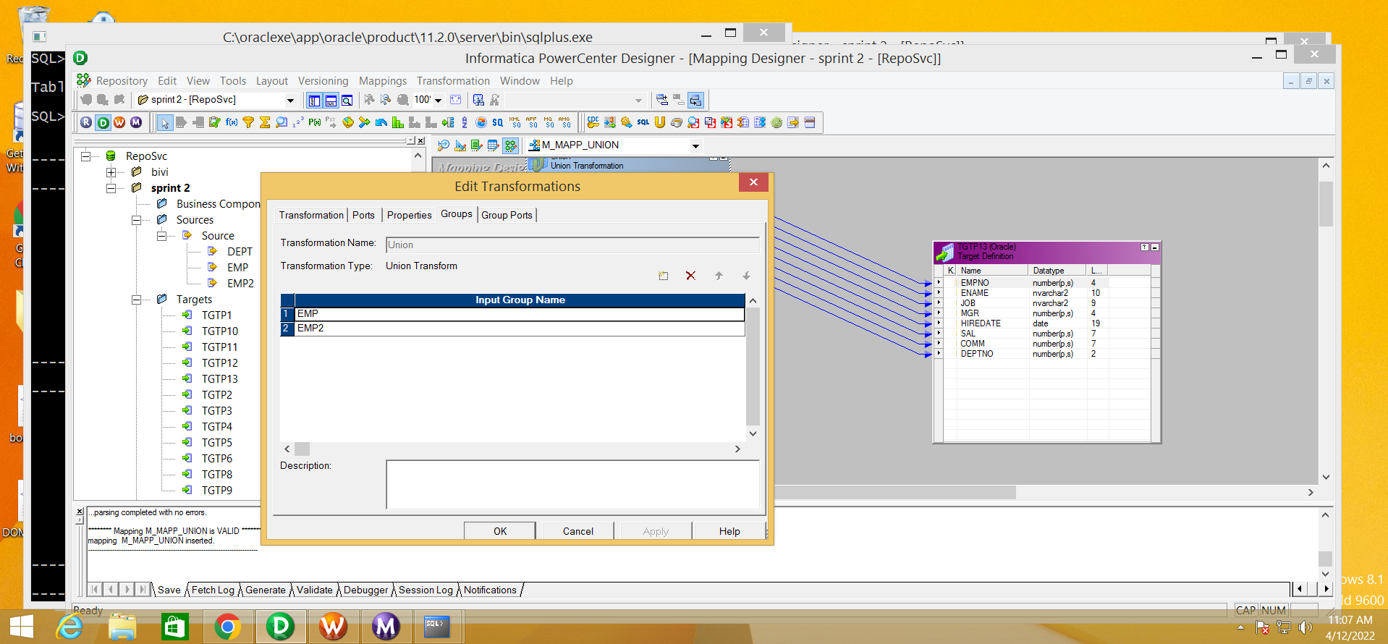

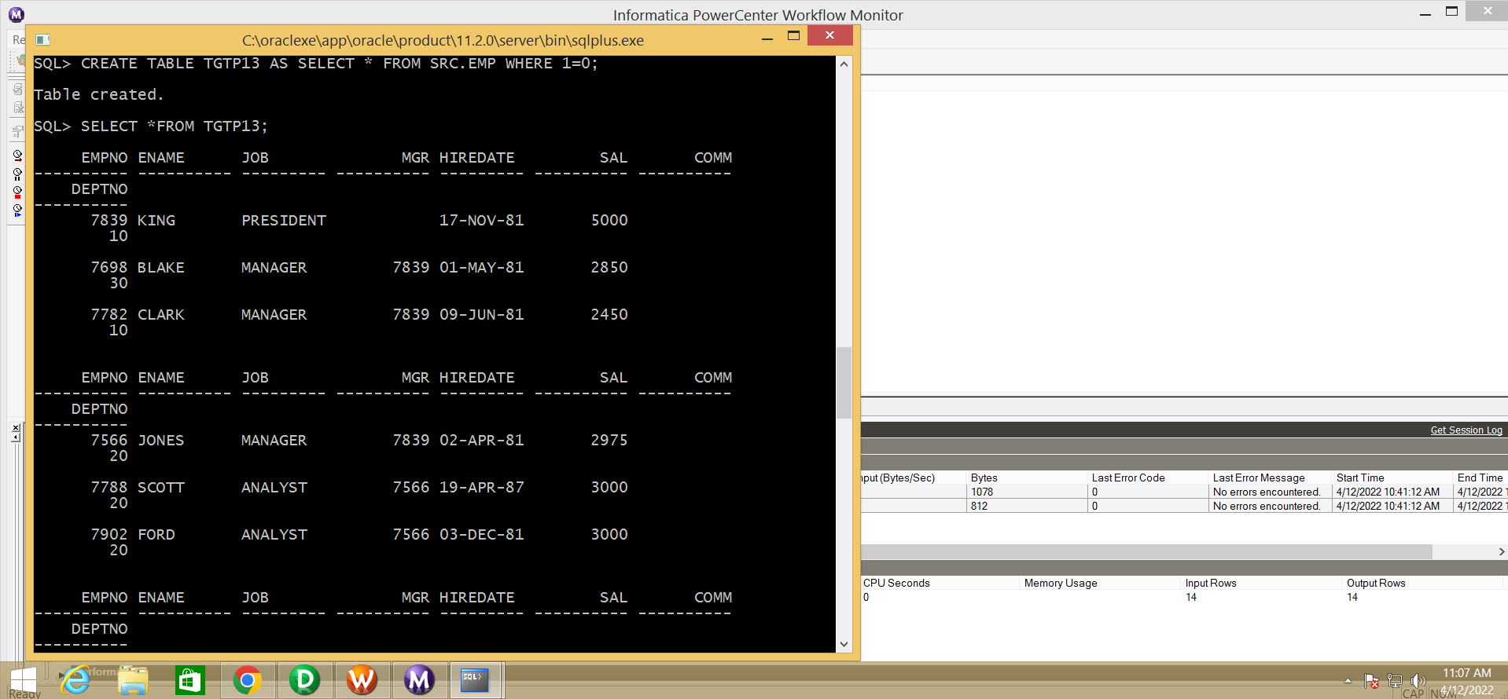

**7. SEQUENCE Transformation :**

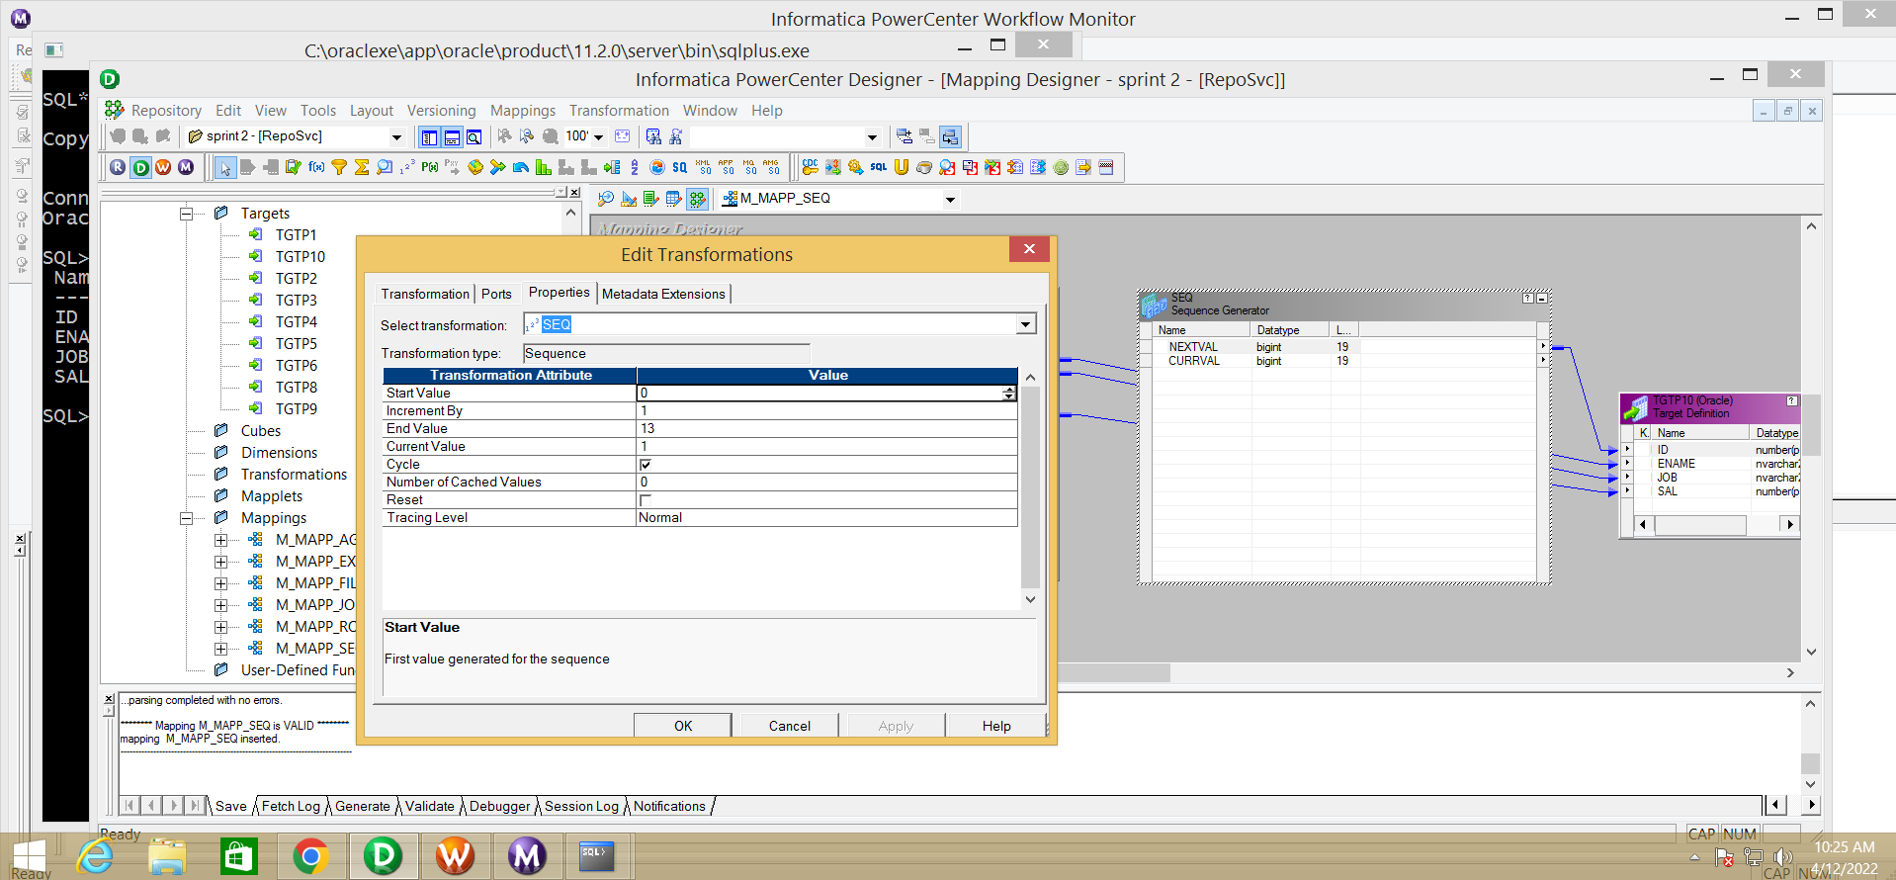

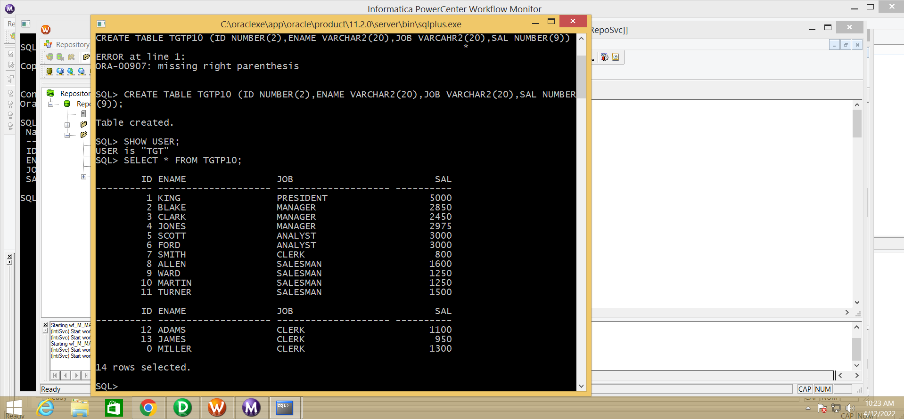

**8. SORT Transformation :**

